

SESSION DE : JANVIER 2019 CENTRE : BORDEAUX
SUJET DE SECOURS

Langue anglaise 1 - CM
LMA1M113E1

Nature de l'épreuve : QCM (32 questions) | Durée de l'épreuve : 1 heure
Documents non autorisés

Questionnaire à réponses multiples

Répondez aux questions en cochant la ou les bonne(s) réponse(s) sur la grille de réponses fournie séparément.
Une seule grille de réponses vous sera délivrée. Veuillez donc bien prendre connaissance des instructions avant de la compléter.

Consignes de remplissage de la grille de réponses :

- Compléter vos coordonnées.  - Reporter votre numéro d’étudiant et cocher les cases correspondantes à votre numéro d’étudiant.  - Pour chacune des questions, vous devrez noircir (uniquement en noir ou en bleu) la case correspondante à votre réponse sur la première ligne.  - Pour corriger votre réponse, utilisez la deuxième ligne sans cocher « annul ». Seule cette deuxième ligne sera prise en compte au moment de la correction, quel que soit le marquage de la première ligne.  - Pour que la totalité de vos réponses de la 1ère et de la 2ème ligne soit annulée, cochez la case « Annul.» se trouvant sous le numéro de la question. Ceci équivaut à une absence complète de réponse. |  | 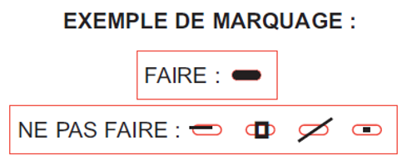  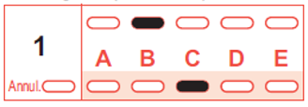  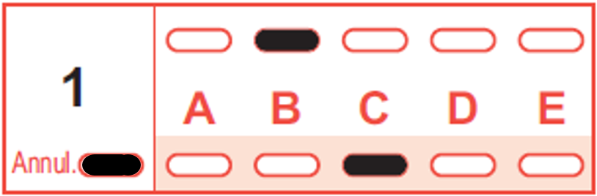 |  | 1ère ligne  2ème ligne  1ère ligne  2ème ligne
Le barème est le suivant :

Type de réponse | Nombre de points
Réponse juste | + 3
Réponse fausse | - 1
Absence de réponse | 0
Réponses incomplètes | Comprenant uniquement des réponses justes : nombre de points proportionnel au nombre de réponses justes.
Réponses incomplètes | Comprenant au moins une réponse fausse : nombre de point = 0

CULTURE AND ENVIRONMENTAL ISSUES

1. Which city is shown to have a state-of-the-art recycling plant?
a) London
b) Belfast
c) Edimburgh
d) Cardiff
e) Liverpool

2. Which of these cities did we not visit as part of the course?
a) Manchester
b) Belfast
c) Birmingham
d) Swansea
e) Liverpool

3. Which of these cities are located in England?
a) Manchester
b) Belfast
c) Edimburgh
d) Cardiff
e) Liverpool

4. Which of these environmental issues are covered in the course?
a) Renewable energy
b) Fracking
c) Nuclear radiation
d) Drought
e) Electric cars

5. Which of these cities do NOT boast a landmark whose name starts with the word “millenium”?
a) Manchester
b) London
c) Edimburgh
d) Cardiff
e) Belfast

6. Which of these cities is not located in Great Britain?
a) London
b) Belfast
c) Edimburgh
d) Cardiff
e) Liverpool

7. Which of these landmarks are located in Cardiff?
a) The Red Dragon Centre
b) Camden Town
c) Roald Dahl’s Plass
d) the city’s most famous pub, The Crown
e) The Three Graces

8. Which home country boasts the second-largest windfarm in Europe?
a) England
b) Scotland
c) Northern Ireland
d) Wales

ORAL COMPREHENSION

9. What does the green party say is mainly responsible for most of the air pollution in London?
a) Traffic
b) Industry
c) Incinerators
d) Home heating and cooking

10. Which of the following statements applies to Lightsource’s facility in Northern Ireland?
a) Their core business is sheep breeding
b) It was built jointly by French companies EDF and Areva
c) They could help farmers diversify their revenue and
provide them with an extra income
d) They own and operate Belfast International Airport

11. What are Lightsource’s future plans?
a) They want to supply 100% of the electricity in Ireland
by 2020
b) They want to sell their electricity to EDF
c) They are going to leave Northern Ireland after Brexit
d) They would like to talk to anyone who owns land
next to a facility which uses a lot of electricity

12. Which of these statements describe the Glencorse water treatment facility?
a) It provides drinking water for half the population of
England
b) It was shut down because it released too many chemicals
c) It boasts the largest grass roof in Scotland
d) The water moves from the reservoirs to the plant
thanks to gravity alone

13. Which of the following statements applies to Welsh farmer Alan Williams?
a) He’s got his own TV show about sheep breeding
b) He rents cottages out to tourists for extra income
c) He set up a water treatment plant on his farm
d) He advises other farmers on how to earn extra revenue

14. What can be said about the New Britain Oils company?
a) They are being accused of being responsible for the increase in obesity in the UK
b) They import palm oil from South America
c) They have launched a campaign to promote the use of palm oil in food
d) They operate a state-of-the-art palm oil refining plant in Liverpool

15. Which of these statements describes the palm oil industry?
a) The UK is the largest consummer in the world
b) India is the world’s largest importer
c) It plays an essential part in protecting the environment
d) Palm oil is banned in Indonesia and Malaysia

16. Which of these issues was discussed during the public consultation on Manchester’s Climate Change Strategy?
a) Windfarms
b) Solar power
c) Uncertain food supply in El Salvador
d) hydroelectric power plants

WRITING

17. Which sentence(s) is/are not correct about note taking?
a) Notes should consist of key words or very short sentence.
b) It it useful to record examples and illustrations.
c) In the Cornell note taking system, a blank row is left at the end of a section for a summary.

18. Which sentence(s) is/are correct?
a) Supporting sentences can include figures and examples.
b) A paragraph can end on a supporting sentence.
c) Concluding sentences should always bring new ideas.

19. A well-built paragraph must show coherence, which can be achieved... :
a) ... by repeating the controlling idea regularly.
b) ... by keeping it as short as possible.
c) ... by using transition signals.

20. Transition signals...
a) ... give coherence to a text.
b) ... cannot introduce additional ideas.
c) ... can introduce examples.

21. Globally, with smoking on the decline, air pollution now causes more deaths annually than tobacco. ..........., researchers think the harm known to be caused by air pollution, ........... heart attacks and lung disease, is only “the tip of the iceberg”.
a) However / such as
b) But / like
c) Yet / as for example

22. Evidence that an entire class of pesticides threatens the health of children and pregnant women is now so arresting that the substances should be banned, an expert panel of toxicologists has said. Terbufos, ............., has been linked to lung cancer, leukaemia and non-Hodgkin lymphoma, .......... in the US, methamidophos has ranked second in the percentage of cases displaying signs of life-threatening symptoms.
a) for instance / while
b) then / whereas
c) thus / although

23. Colons are used...
a) ... to introduce an explanation. (ex: Tai chi is more than mere physical exercise: it is meditation in movement.)
b) ... to introduce a list (except after to be). (ex: To me, the most important things in life are the following: good health, a happy home life, and a satisfying occupation.)
c) ... before connectors. (ex: My bus was late: therefore, I missed my first class.)

24. Which is the best punctuation?
a) The Times of London recently published an article entitled "Who Needs the Monarchy?" in which the relevancy of the English monarchy was discussed.
b) The Times of London recently published an article entitled "Who Needs the Monarchy?" in which the relevancy of the English monarchy was discussed.
c) The "Times" of London recently published an article entitled Who Needs the Monarchy? in which the relevancy of the English monarchy was discussed.
ENGLISH PRONUNCIATION

25. Choose the word or words which have a vowel sound that is represented by the symbol /i:/.
a) feet
b) fit
c) green
d) grin

26. Choose the word or words which have a vowel sound that is represented by the symbol /ɔː/ .
a) drought
b) bored
c) soak
d) great

27. Choose the word or words which have a vowel sound that is represented by the symbol /əʊ/ .
a) play
b) fine
c) home
d) feel

28. Choose the word or words which have a vowel sound that is represented by the symbol /u:/ .
a) rain
b) cut
c) cute
d) snow

29. Choose the word or words which have a vowel sound that is represented by the symbol /eɪə/ .
a) player
b) power
c) fire
d) lower

30. Which one of the following words corresponds to this phonetic transcription: /'dæmɪdʒ/?
a) demons
b) damsons
c) damage
d) deluge

31. Is the underlined consonant in the following word aspirated (voiceless) or voiced: “factories”
a) voiced
b) aspirated

32. Which of the following phonetic transcriptions is the correct one for the word “warmed”?
a) /wɔːmt/
b) /wɔːmd/
c) /wɔːmɪd/
d) /wɔːmed/

